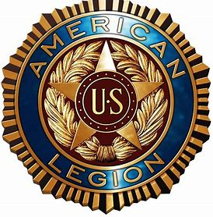
American Legion Post 24 Kirby Stewart
2000 75th St . W.Bradenton, FL 34209,
November 16th, 2021 at 1pm,
Post Service Office Presents: VA Benefits and Services for Senior Veterans
With special guest professionals’ presenters from the Manasota Area
- Kathy Sugent, Business Development Director, from Brookdale Senior Living Center, on how to apply our DIC VA Benefit utilized at a VA approved Senior Living Facility
- Jason Krywko, BC-HIS Board Certified in Hearing Instrument Sciences, EarTech, EarTech is a family-owned-and-operated practice that offers a relaxed and personalized atmosphere within their state-of-the-art hearing aid facility
- Debbie Carlson, NURSE ON CALL is a Proprietary, Medicare Certified, home health care agency located in BRADENTON, FL. This agency has been certified to participate in Medicare programs since July 25, 2001 and given a rating of 4.5 stars. A rating if 4-5 stars would mean the agency performed better than others regarding care practices and outcome.
- Right Accord Private Duty Health Services, is a Florida based, family owned and operated Home Health Care Service. We are very passionate about helping seniors staying in their home. Giving the relatives peace of mind
- Sammy Simpkins, Funeral Director for Griffith Cline Funeral Services, on how to be in termed at the National Cemetery through funeral services.
Senior Veterans are encouraged to attend this important event.
RSVP: To American Legion Post 24, Service Officer Ed Padilla, as there will be refreshments available.

